Course Code: |  |  | : | AI244AI | Date | : | 19-06-2024
Semester |  |  | : | IV | Time | : | 12:00 – 1:30 PM
Max Marks |  |  | : | 50 | Duration | : | 90 mins
Artificial Intelligence and Machine Learning
CIE 1
Note: Answer all the Questions
SL. No |  | Questions |  |  |  |  |  | M | BT | CO
1 | a | A chatbot is an artificial intelligence (AI) software that can simulate a conversation (or a chat) with a user in natural language through messaging applications, websites, mobile apps, or through the telephone. Give a PEAS description of a chatbot that is used to promote cultural events in a college and justify your description. |  |  |  |  |  | 5 | L3 | CO1
 | b | Mention the types of environments suitable for the following tasks and justify your selection briefly;  - The agent monitors the boiler's temperature in a manufacturing plant.  - Agent-detecting network attacks |  |  |  |  |  | 5 | L3 | CO1
2 | a | Differentiate the working of the simple-reflex agents and model-based reflex agents. |  |  |  |  |  | 5 | L2 | CO1
 | b | By considering any of the domains, such as healthcare, retail, autonomous cars, or others, list four areas for the application of Artificial Intelligence. |  |  |  |  |  | 5 | L3 | CO1
3 | a | Compare various types of machine learning techniques and their categories with suitable applications. |  |  |  |  |  | 5 | L2 | CO1
 | b | Illustrate the bias-variance trade-off issue in machine learning. Identify the techniques used to avoid overfitting and underfitting scenarios. |  |  |  |  |  | 5 | L2 | CO2
4 |  | Consider the following data: the Y label is whether or not the child goes out to play. Calculate the following:  Day Weather Temperature Humidity Wind Play?  1 Sunny Hot High Weak No  2 Cloudy Hot High Weak Yes  3 Sunny Mild Normal Strong Yes  4 Cloudy Mild High Strong Yes  5 Rainy Mild High Strong No  6 Rainy Cool Normal Strong No  7 Rainy Mild High Weak Yes  8 Sunny Hot High Strong No  9 Cloudy Hot Normal Weak Yes  10 Rainy Mild High Strong No  - Calculate the IG (information gain) for each attribute (feature)  - Choose which feature to split with and repeat for each level.  - Choose a feature for each node to split on  - Build Final Tree |  |  |  |  |  | 10 | L3 | CO5
5 | a | The following data are recorded while predicting the spam email using a classification model.  - Correct prediction – 0 spam, 75 non-spam  - Incorrect prediction- 30 spam, 700 non-spam  Calculate the Accuracy, sensitivity, precision, and F-measure of the model. Identify the problem with the above classification model. |  |  |  |  |  | 5 | L3 | CO5
5 | b | Analyze and identify issues in the following machine learning scenarios and propose solutions (s) for them  - A student dataset has an employee age value of 230.  - An object recognition model training set error is 95%, and the test set error is 15%.  - Malignant tumour classification model training set error is 25%, and test set error is 23%. |  |  |  |  |  | 5 | L4 | CO1

M-Marks, BT-Blooms Taxonomy Levels, CO-Course Outcomes
Marks Distribution | Particulars | CO1 | CO2 | CO3 | CO4 | CO5 | L1 | L2 | L3 | L4 | L5 | L6
 | Max Marks CIE | 30 | 5 | - | - | 15 | - | 15 | 30 | 5 | - | -

Course Outcomes: After completing the course, the students will be able to:-
CO1 | Explain and apply AI & ML algorithms to address various requirements of real-world problems
CO2 | Design and develop AI and ML solutions to benefit society, science and industry.
CO3 | Use modern tools to create AI and ML solutions.
CO4 | Demonstrate effective communication through team presentations and reports to analyze the impact of AI and ML solutions on society and nature.
CO5 | Conduct Performance evaluation, modelling and validation of AI and ML solutions benefitting lifelong learning.

Scheme and Solutions
Q. No | Solutions | M
1a. | PEAS Description of the Chatbot to promote cultural events in the college;  SAMPLE ANSWER:  Performance: User Engagement, Event Awareness, User Satisfaction, Conversion Rate, Timeliness, etc. (Any TWO – 2M)  Environment: Digital Platforms, User location and demographics, Mobile, etc. (Any 1 – 1M)  Actuators: Notifications, Advertisements, Messages, etc. (Any 1 – 1M)  Sensors: User data, Event data, Data from Social Networks, etc. (Any 1 – 1M)
1b. | - The Agent Monitors the Boiler's Temperature in a Manufacturing Plant (2.5M)  Suitable Environment: Partially Observable, Dynamic, Continuous, and Deterministic  - Partially Observable: The agent may not have access to all the environmental variables influencing the boiler's temperature, such as external weather conditions or internal pressure variations, making the environment partially observable.  - Dynamic: The boiler's temperature can change rapidly due to varying operational conditions, heat exchange processes, and potential malfunctions.  - Continuous: The boiler's temperature is a continuous variable that can take on a wide range of values, requiring precise monitoring and control.  - Deterministic: Given the same initial conditions and inputs, the temperature changes predictably based on known physical principles, leading to deterministic behavior.  Agent Detecting Network Attacks  Suitable Environment: Partially Observable, Dynamic, Discrete, and Stochastic (2.5M)  - Partially Observable: The agent may not have complete visibility into all network activities or the internal workings of connected devices, making the environment partially observable.  - Dynamic: Network conditions and potential attack vectors can change rapidly as new devices connect, data traffic fluctuates, and attackers use different techniques.  - Discrete: Network events, such as packet transfers, connection requests, and alerts, are discrete events that occur at specific times.  - Stochastic: The occurrence of network attacks is probabilistic, with uncertainty in both timing and method, resulting in a stochastic environment
2a. | Simple Reflex Agent: (Diagram: 1M + Discussion 1.5M )  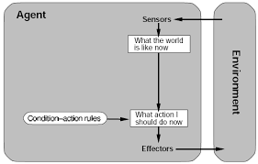  Model-based Reflex Agent: (Diagram: 1M + Discussion 1.5M )  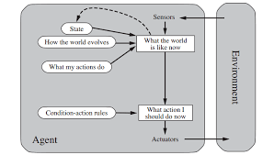
2b. | Each application of AI in a selected domain carries 1.25 M = 1.25 M X 4  EXAMPLE: (Healthcare)  - To create personalized treatment plans  - Healthcare data analysis  - Disease prediction  - Patient Monitoring
3a. | Supervised machine learning Unsupervised machine learning Reinforcement  Used for classifying (classes and labels are given) To find pattern (No idea about class/labels) Rewards – if guessed correctly (No idea about class/labels)  Labelled training data Unknown and unlabeled data Model learns and updates itself through rewards/punishment  Classification and regression Clustering and association analysis No such types  Simple to understand More difficult to understand and implement Most complex  Navie bayes, KNN, LR, SVM etc Kmeans, PCA, DBSCAN, apriori Q-Learning, Sarsa  Hand writing recognition, stock market prediction, disease prediction, fraud detection Market based analysis, recommender system, customer segmentation Self driving cars, intelligent robots | 05
3b. | 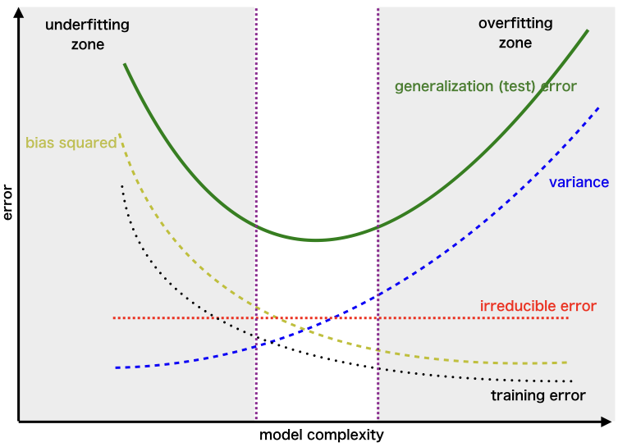  To avoid overfitting (high variance), try the following –  - Increase the training data (collecting more data/augment the training dataset)  - Less complex model  - Early stop (reduce epochs)  - Remove features (not recommended)  - Assembling  - L1/L2 regularization to simplify your model.  To avoid underfitting (high bias):  - Try to increase complexity of model  - Train for longer time  - Try to increase the number of features by finding new features or making new features from the existing ones.  - Decrease regularization  - Use different model | 05
4. | Initial entropy = 𝐻(𝑌) = − ∑ 𝑃(𝑌 = 𝑦) log2 𝑃(𝑌 = 𝑦)𝑦  = −𝑃(𝑌 = 𝑦𝑒𝑠) log2 𝑃(𝑌 = 𝑦𝑒𝑠) − 𝑃(𝑌 = 𝑛𝑜) log2 𝑃(𝑌 = 𝑛𝑜)  = −(0.5) log2(0.5) − (0.5) log2(0.5) = 1  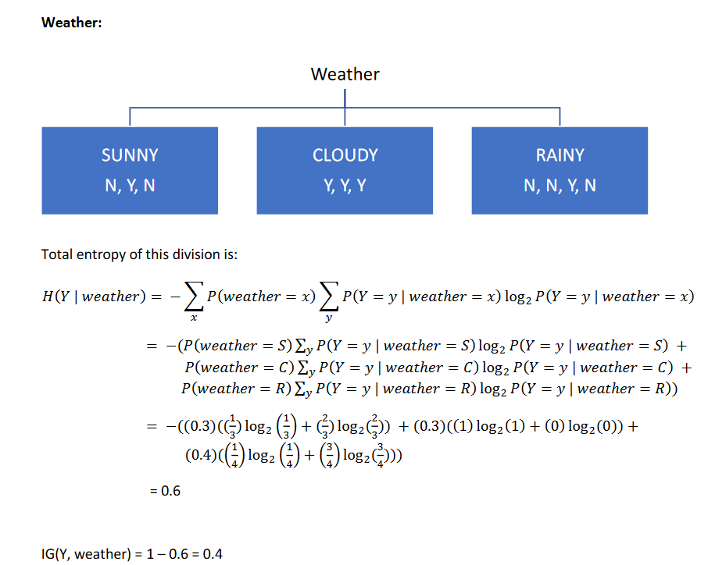  IG = 1-0.7884 = 0.2116  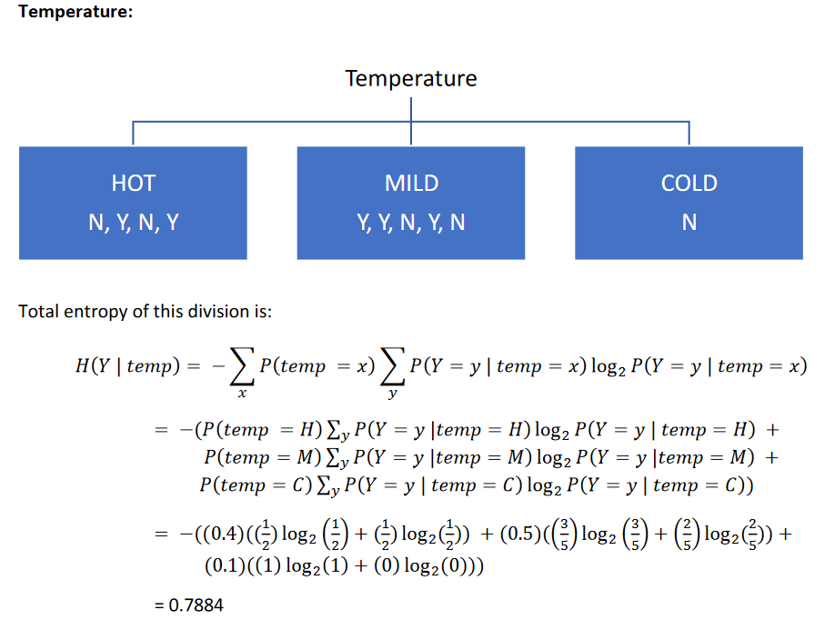  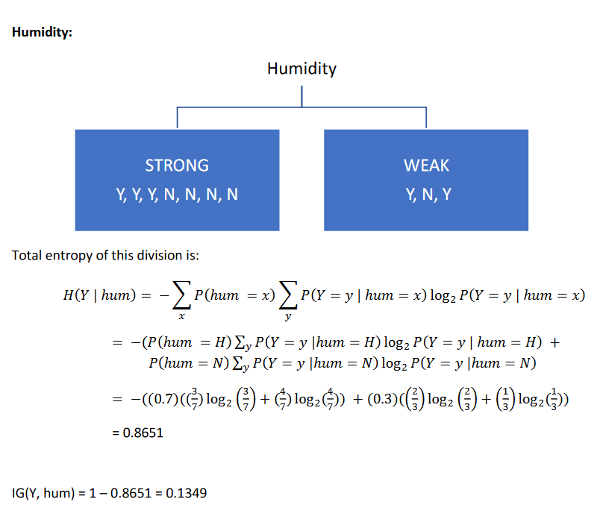  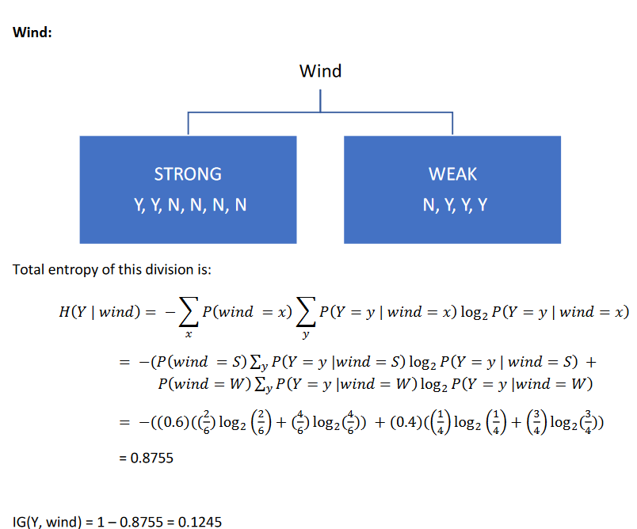  IG(Y, wind) = 0.1245  IG(Y, hum) = 0.1349  IG(Y, weather) = 0.4  IG(Y, temp) = 0.2116  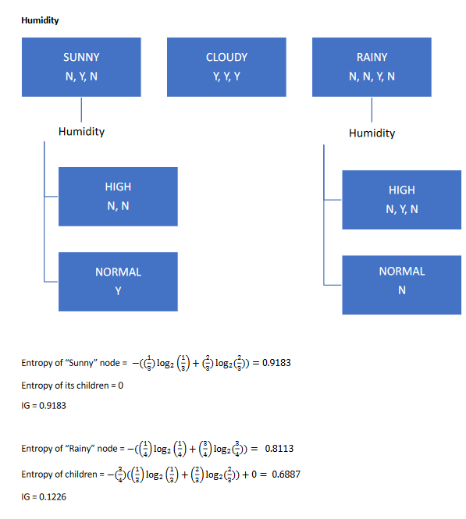  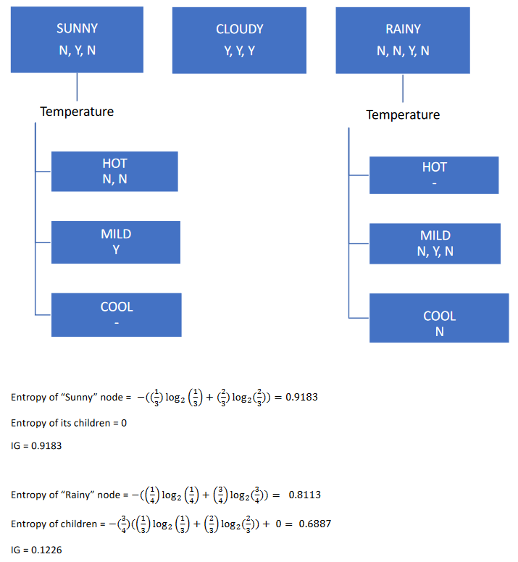  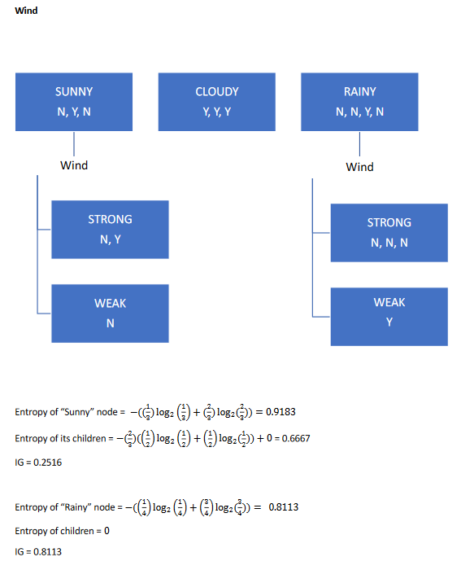  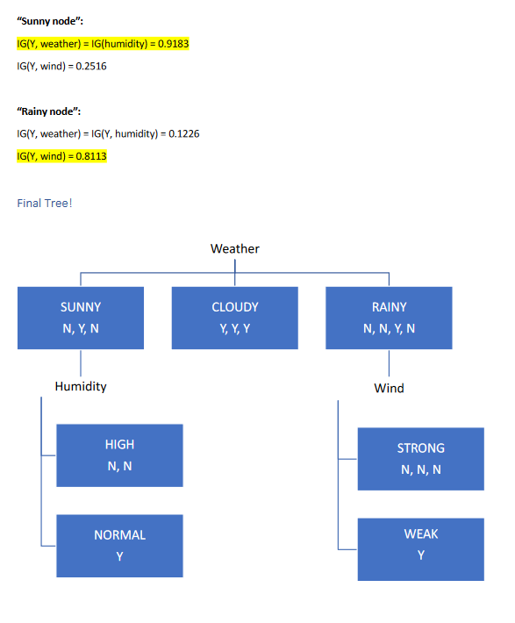 | 10
5a. | Accuracy=0.8697, sensitivity= 0.0323, precision= 0.0132 and F-measure of the  model. Identify the problem with above classification model. It is imbalanced  dataset. The model failed to predict positive class instances | 05
5b. | A student dataset has an employee age value as 230.  Outlier, impute with avg, median or other suitable values.  b. An object recognition model training set error is 95% and test set error is  15%. overfitting, decrease model complexity.  c. Malignant tumor classification model training set error is 25% and test set  error is 23%. underfitting, increase model complexity. | 05

